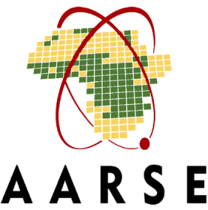

AARSE2022 Conference 2022
Side Events
Application Form | Template

Please find below a template application form to prepare your side event proposal. We would kindly ask you to submit the final application via EMAIL and use this template form for your internal purposes only. You can find the online application form here:
Application forms can be submitted until September 30, 2022. Please note that only duly completed applications will be taken into consideration. We would kindly ask you to read the Application Guidelines carefully before completing your application. They contain useful information on the scope, formats, and relevant costs of AARSE2022 Conference side events. Should you have any questions, please do not hesitate to contact the AARSE2022 Conference local organizing Committee at jossam2003@ines.ac.rw

- Organizer details
Host Organization

Short Description
Please provide a short description of your organization, detailing your area of expertise and mission statement (running text, max. 100 words).
Summary
Summarize your organization in one sentence. Please note that this summary will be added to your event description on the MSC Portal.
Point of Contact E-mail
Office no.

Mobile no.

Co-Host Organization (Optional)

Short Description
Please provide a short description of your organization, detailing your area of expertise and mission statement (running text, max. 100 words).
Summary
Summarize your organization in one sentence. Please note that this summary will be added to your event description on the MSC Portal.
Point of Contact E-mail
Office no.

Mobile no.

- Event title

- Event objective

- Event format

Breakfast Lunch Dinner
□
□
□
□
□
□
Roundtable discussion Interactive conference discussion

Reception

Other, please specify:
□

